Documentation on AWS S3

Introduction:

**Amazon S3** (Simple Storage Service) is a scalable, high-speed, low-cost web-based service designed for online backup and archiving of data and application programs. It allows to upload, store, and download any type of files up to 5 TB in size. This service allows the subscribers to access the same systems that Amazon uses to run its own web sites. The subscriber has control over the accessibility of data, i.e. privately/publicly accessible.

**Overview:**

**Buckets:**

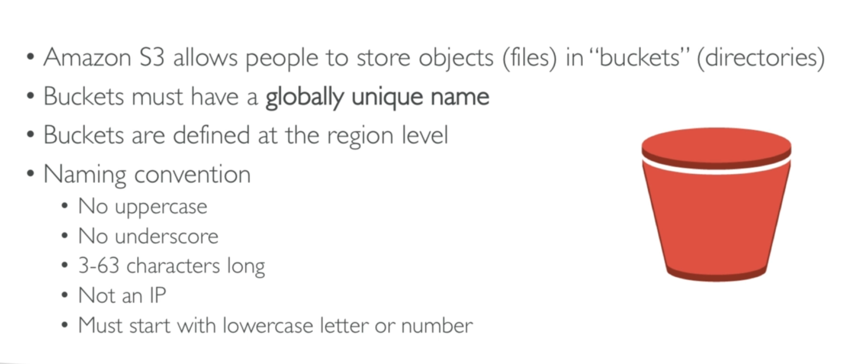

**Objects:**

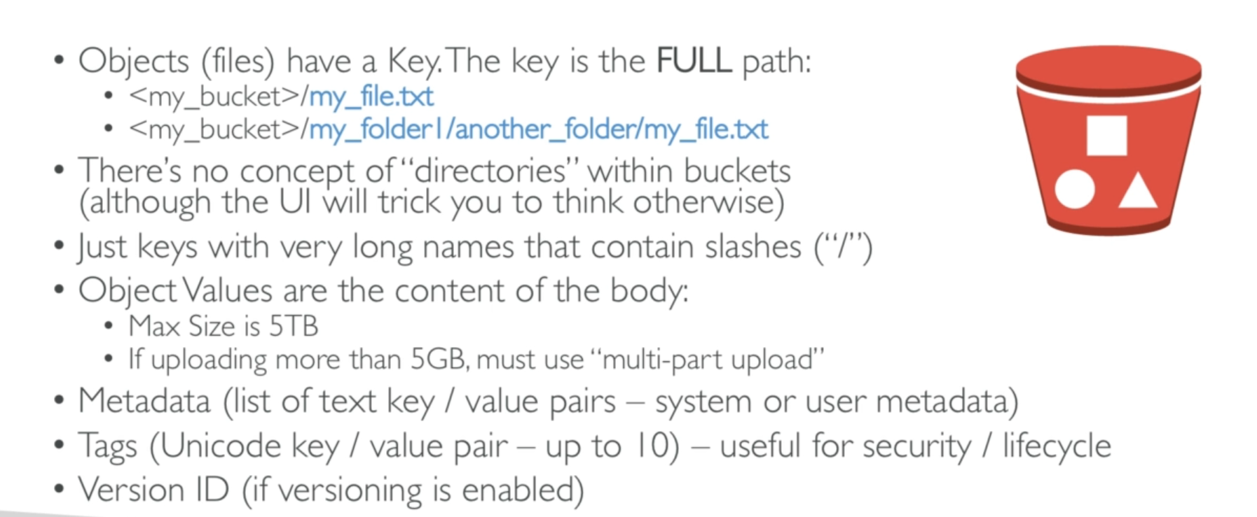

**Note:**

* By default we can make 100 accounts in each aws account But we can increase it upto 1000 by submitting service limit increase.
* S3 is global (no region is required)

**Aws S3 – Versioning**

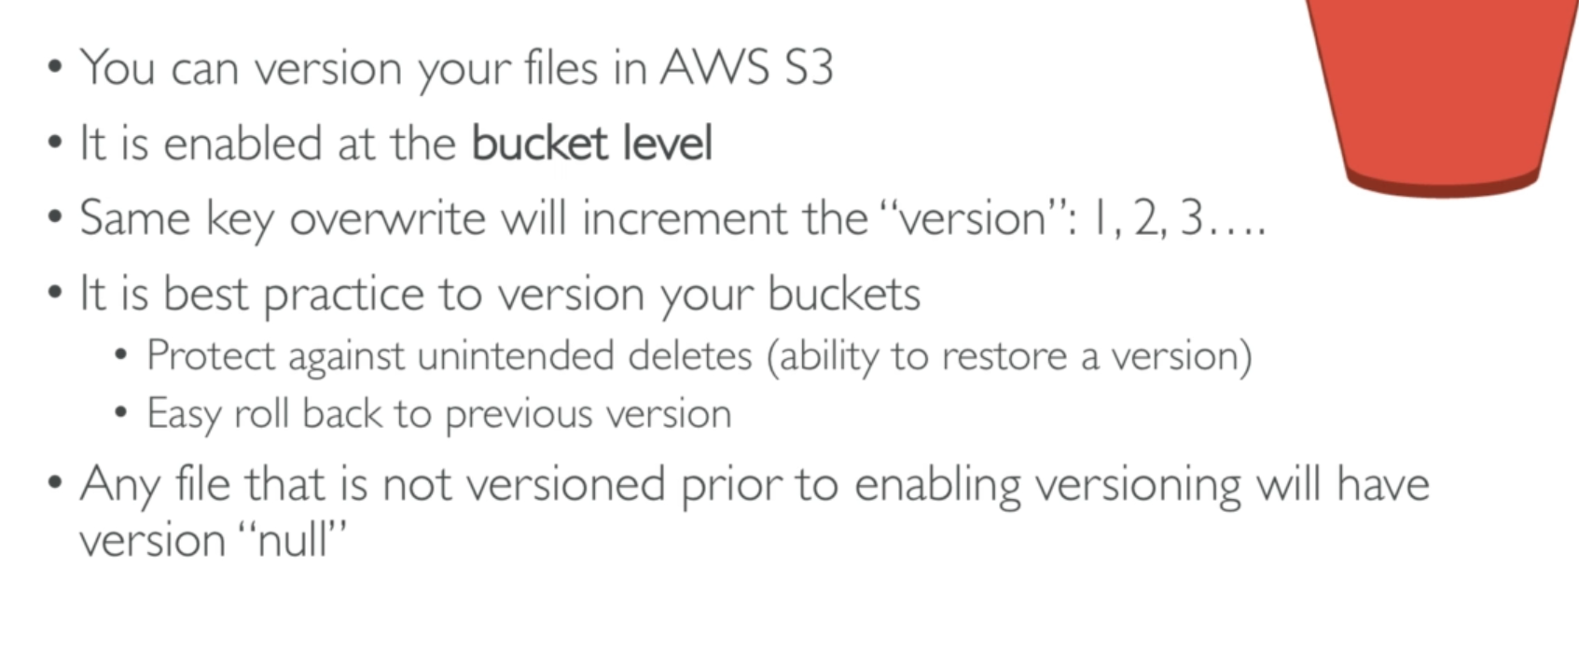

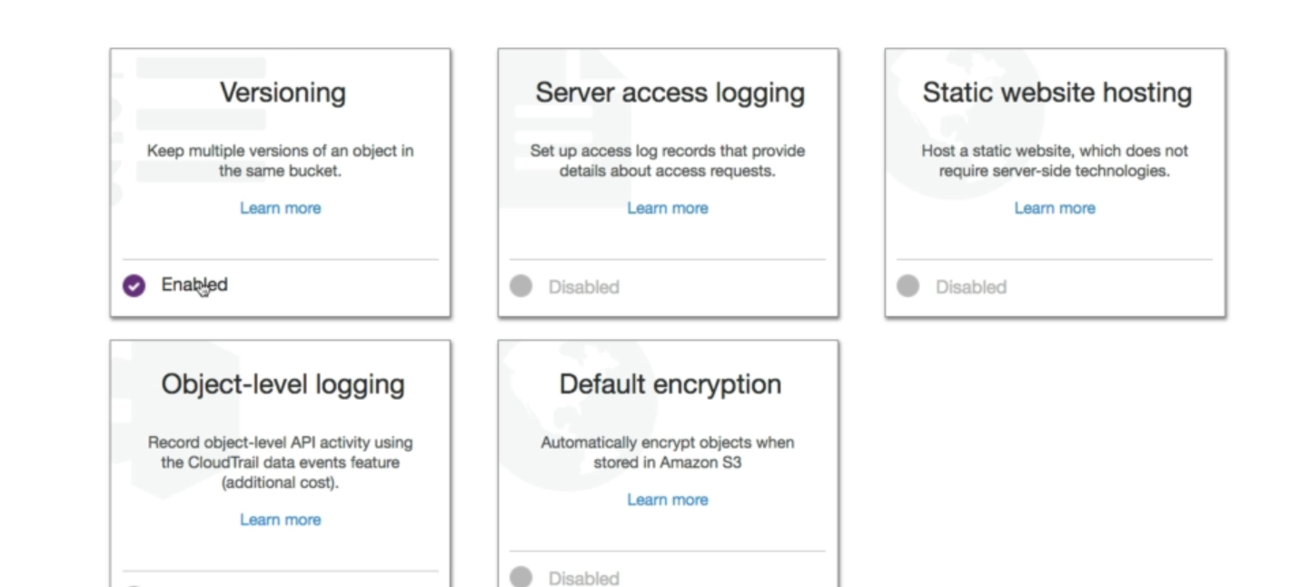

**S3 Encryption for objects:**

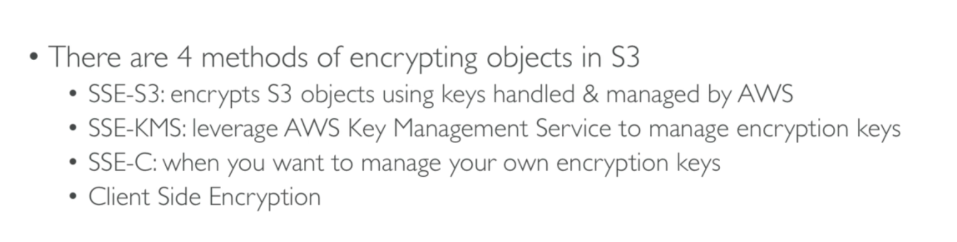

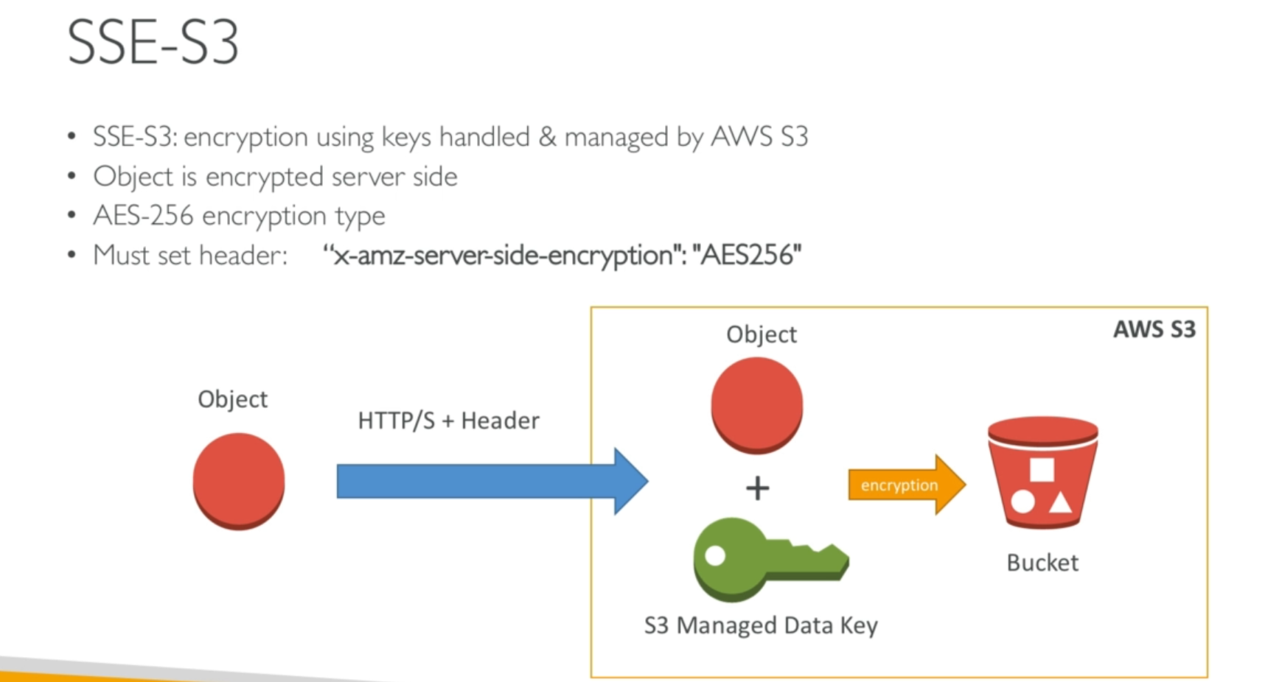

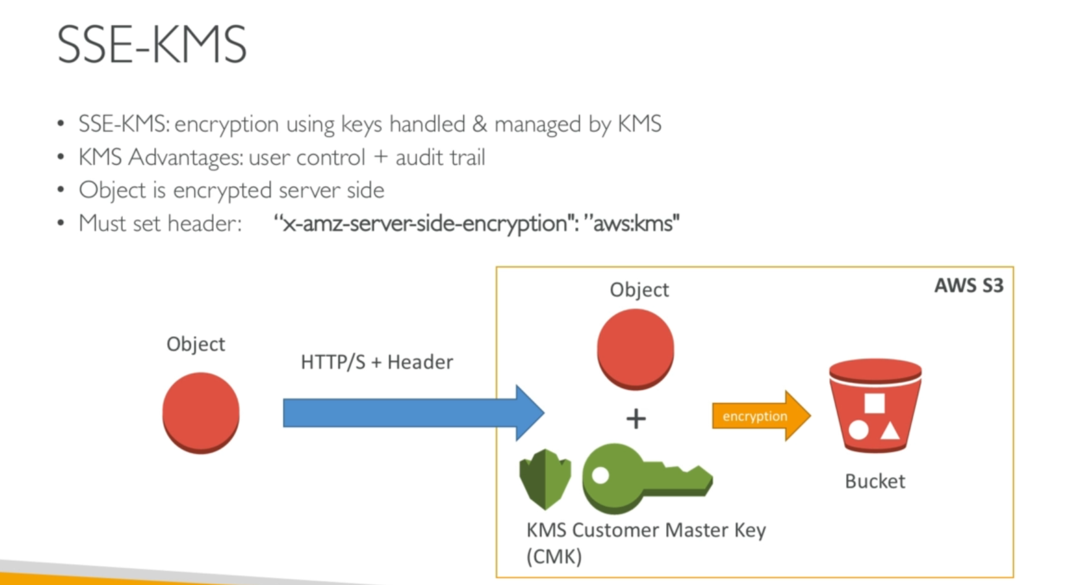

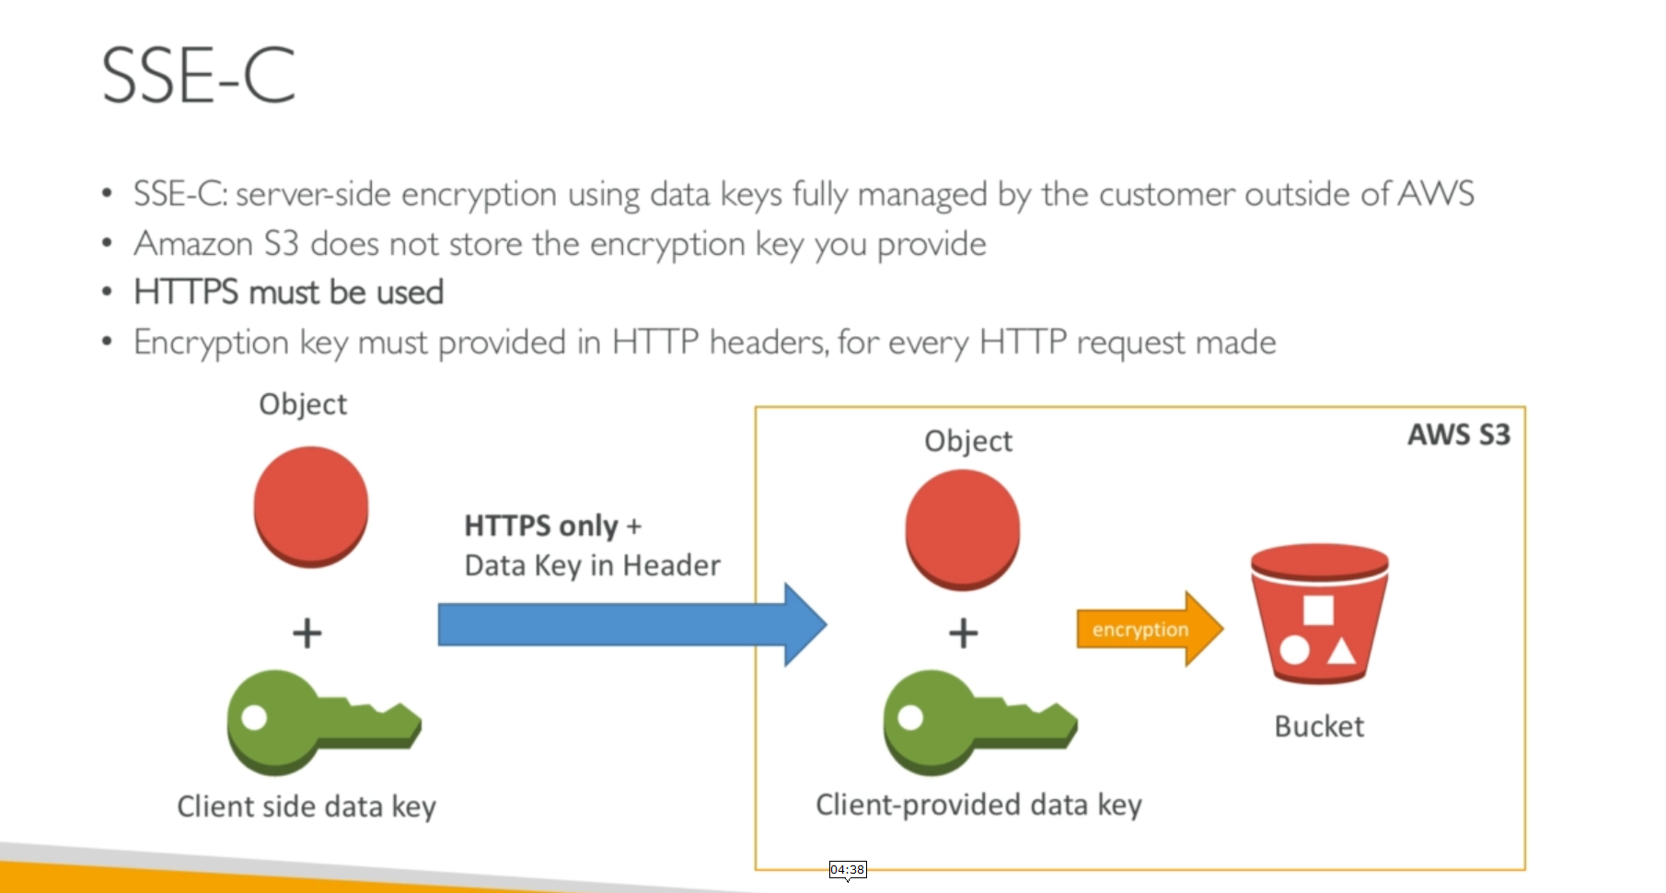

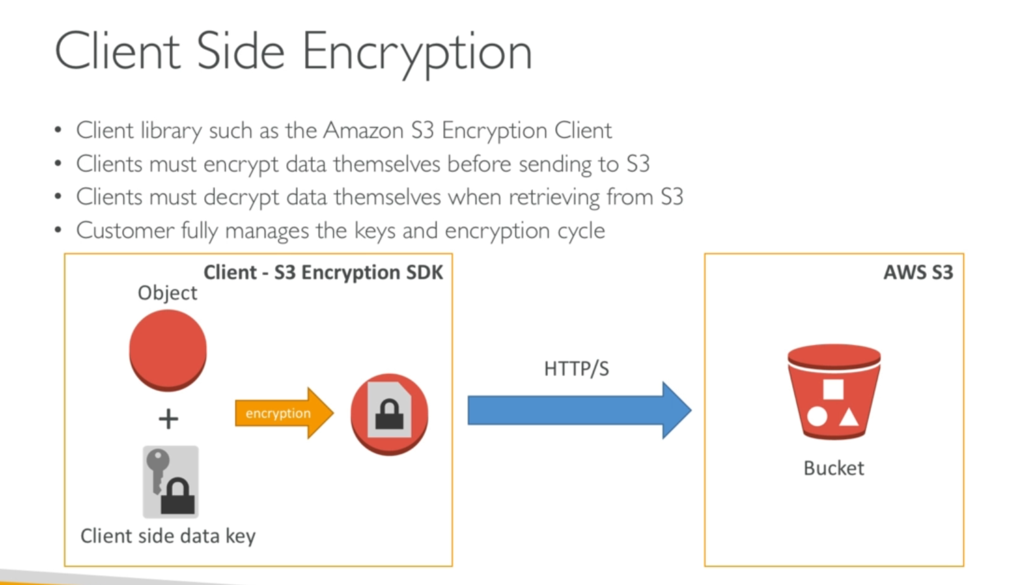

**S3 Security:**

2 types of Security

1. User Based
2. Resource Based

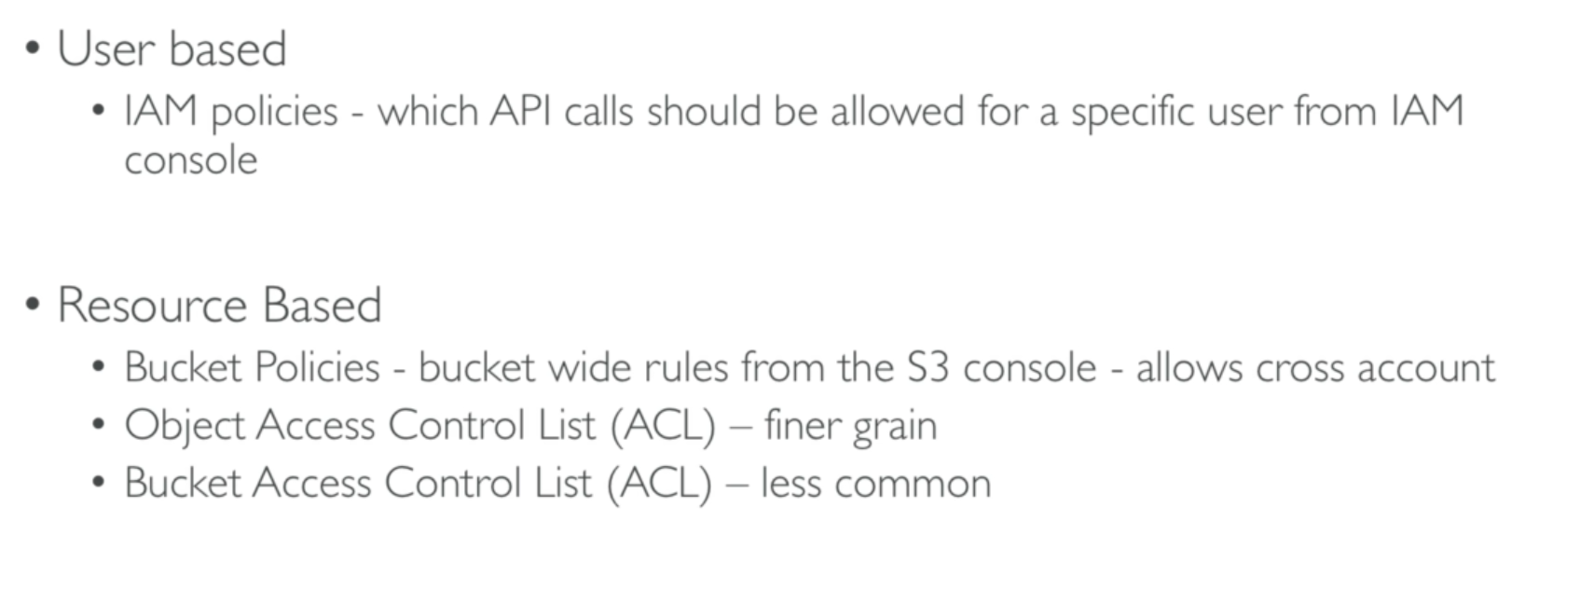

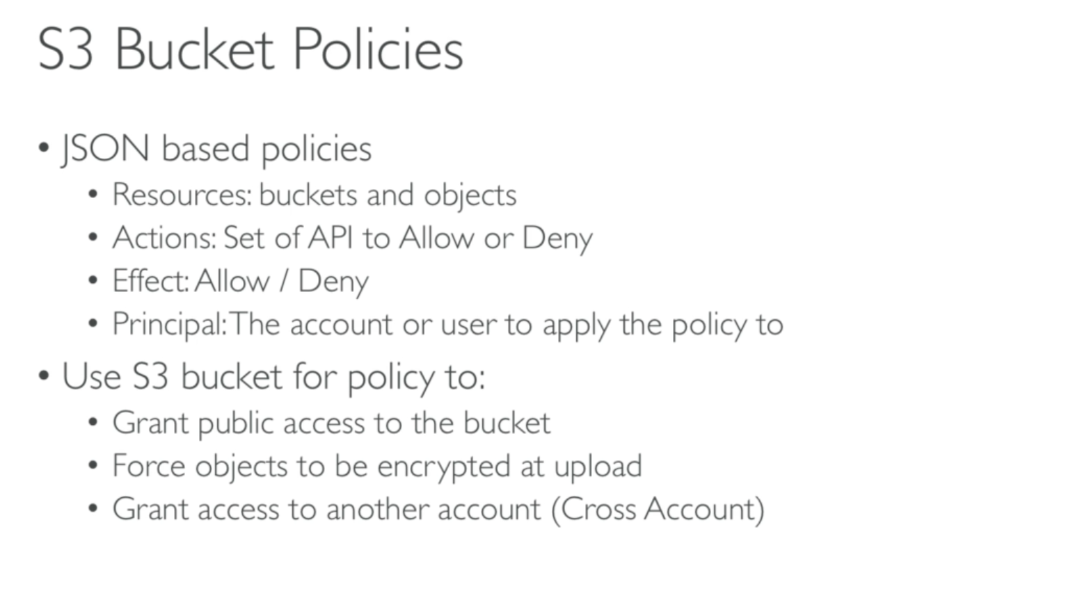

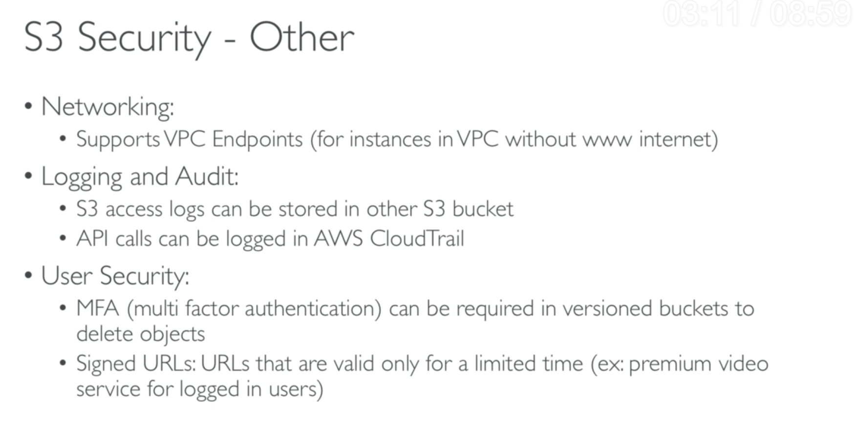

**Bucket Policy**

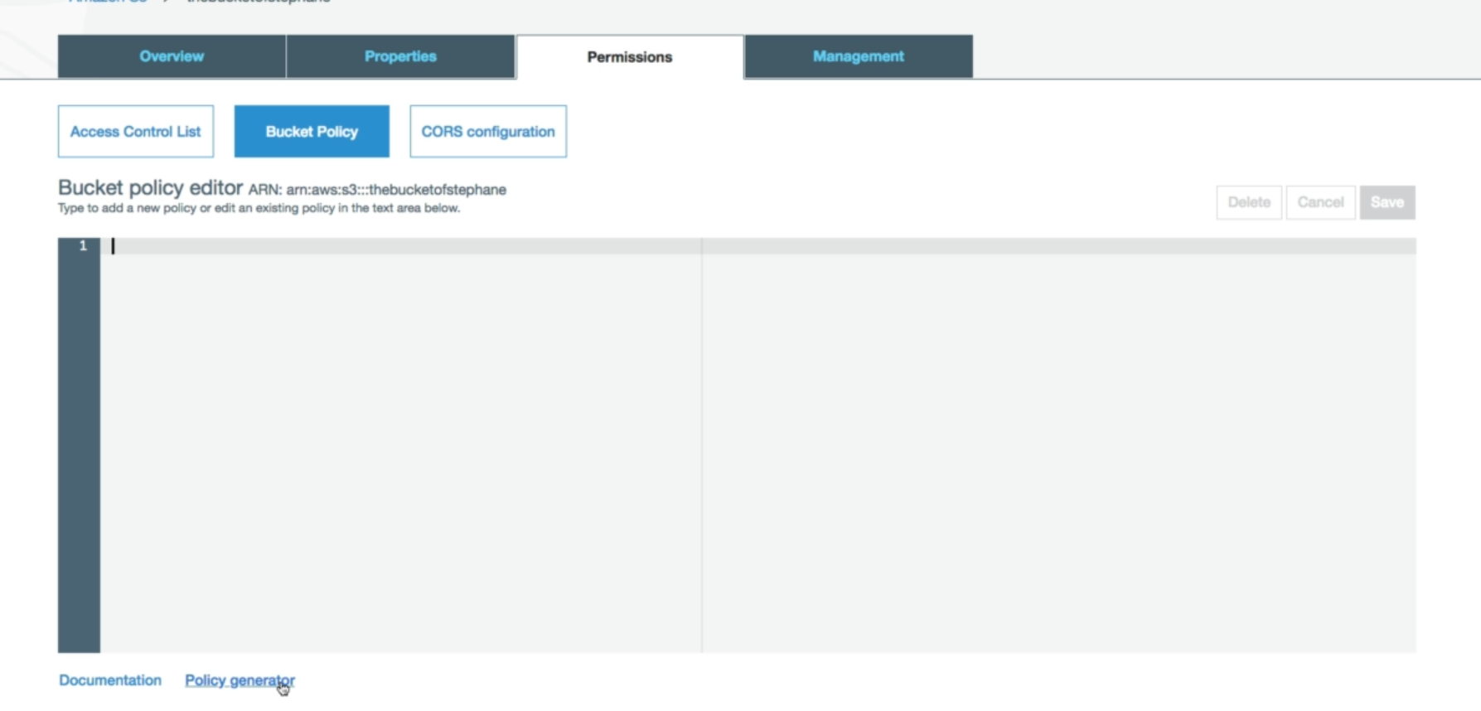

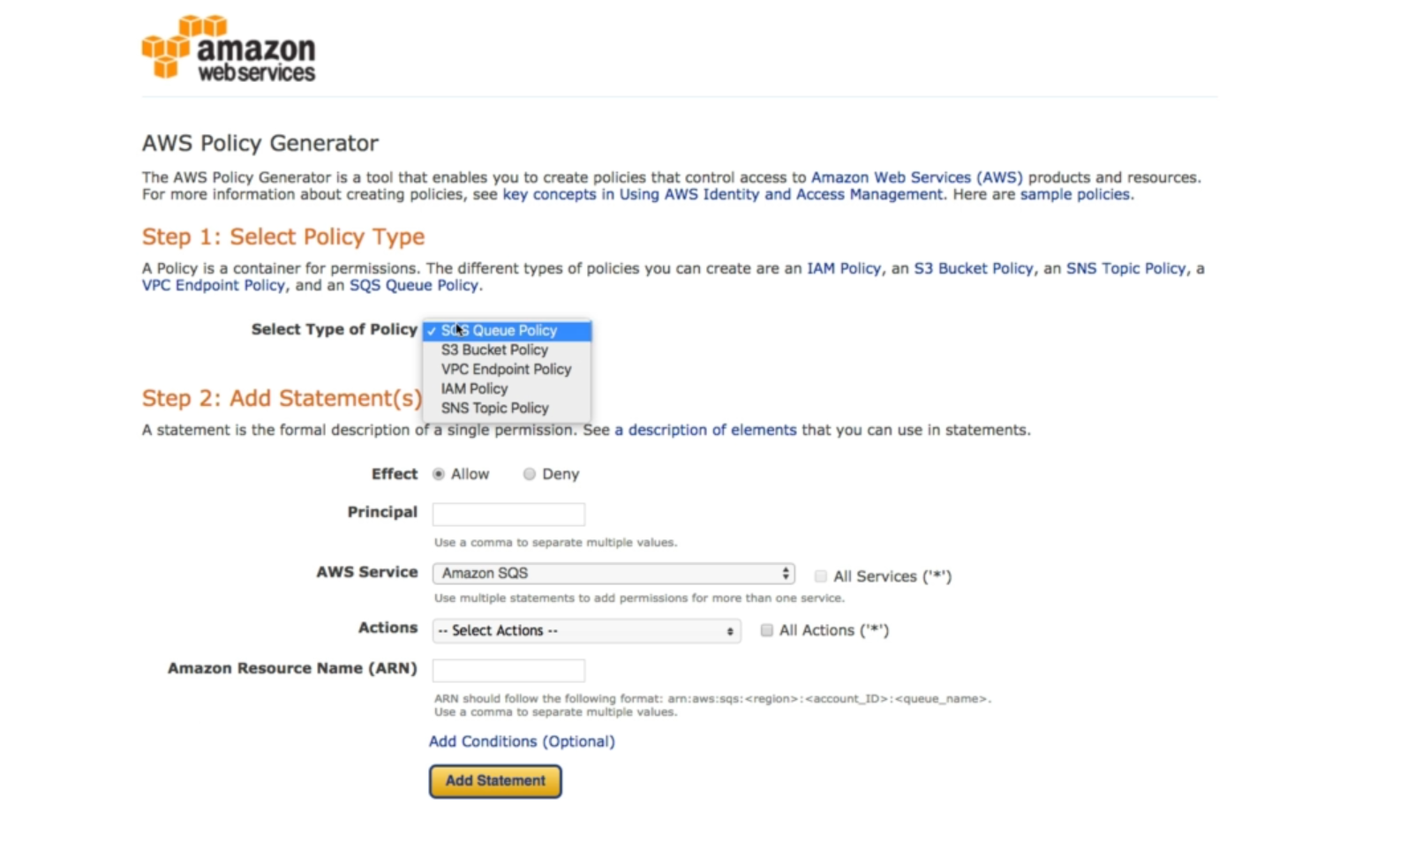

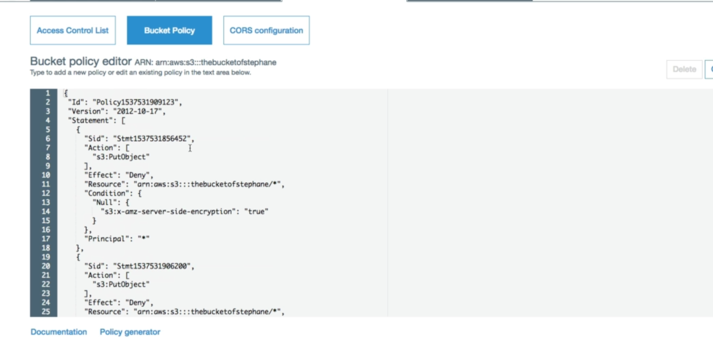

**S3 can also host static websites**

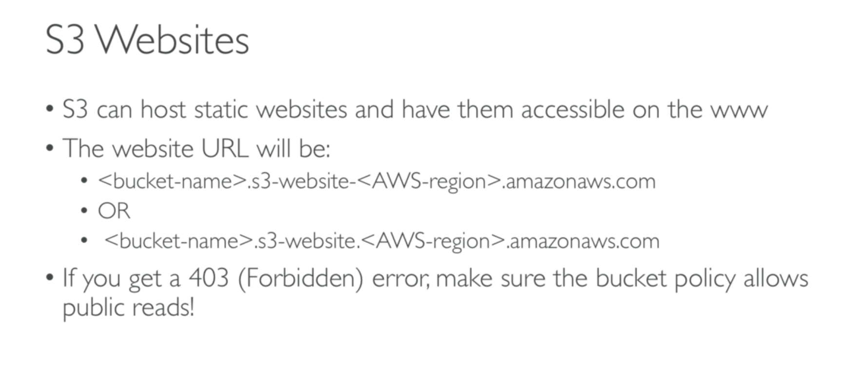

**S3 CORS:**

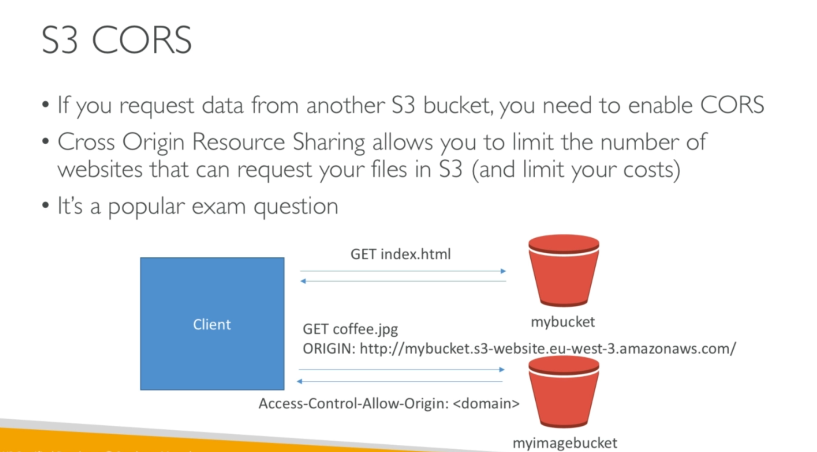

**S3 MFA-DELETE**:

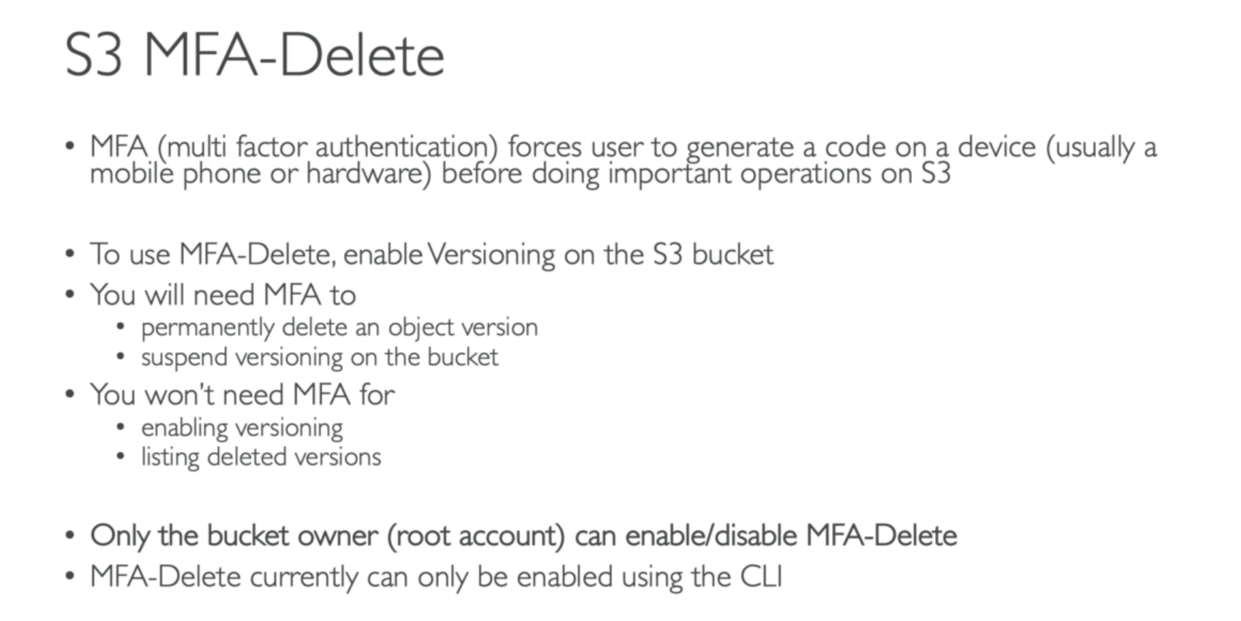

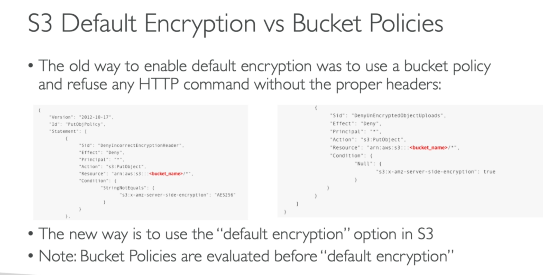

**S3 ACCESS LOGS**:

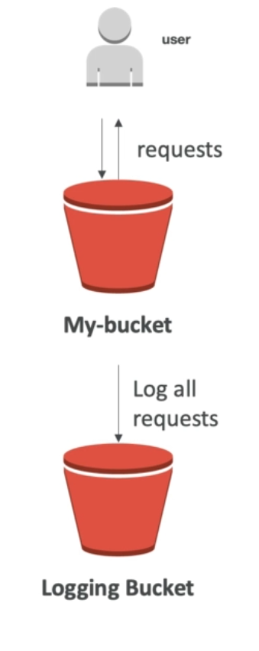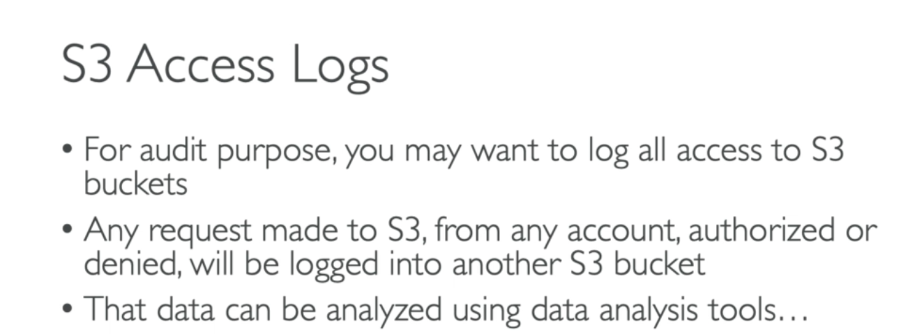

**CROSS REGION REPLICATION:**

